Fast**National University of Computer & Emerging Sciences, Karachi  
Midterm – I solution (Spring-2023)**

**2nd March 2023, 08:30 AM – 09:30 AM**

|  |  |  |
| --- | --- | --- |
| **Course Code: CS3009** | **Course Name: Software Engineering** | |
| **Instructor Name: Hajra Ahmed, Dr. Syed Muazzam Ali Shah, Noureen Fatima** | | |
| **Student Roll No:** | | **Section No:** |

**Questions 1:**

1. ***Functional requirement:***

* The club member should have a member card.
* The customer shall be provided a special discount as per follow-up policy.
* The customer shall pay fees to the club every month.

***Non-Functional requirement:***

* Reliable
* Robust
* High performance
* Secure/Safe
* Should utilize memory/storage effectively.

b) *When members join the health club, they pay a fee for a* ***certain length of time.***

c) **Business requirement changes or emerging changes, or technical changes.**

**Questions 2:**

1. The Capability Maturity Model (CMM) is a framework for assessing the maturity of an organization's software development processes. It consists of five levels of maturity, ranging from an initial ad-hoc process to a fully optimized, continuous improvement process. based on the description of their working environment and the products they produce, it is likely that they are operating at Level 3: Defined of the Capability Maturity Model, given their structured working environment and their focus on producing high-quality innovative products.
2. By writing tests first, developers can also catch potential problems early in the development cycle, before they become more difficult and costly to fix. This approach also helps developers think through the requirements and design of the code before implementation, leading to better overall code quality and maintainability. In summary, the TDD approach helps to validate requirements by providing a clear and structured process for ensuring that the code meets those requirements and by catching potential problems early in the development cycle.

**Questions 3:**

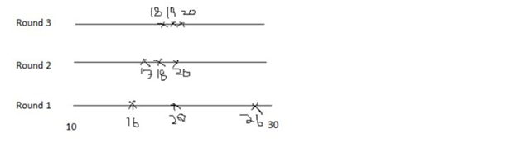a)

b)

|  |  |  |  |  |  |  |
| --- | --- | --- | --- | --- | --- | --- |
|  | Salas | Aliya | Ahmed | Best | Worst | Average |
| Create UI | 3 | 4 | 7 | 3 | 7 | 5 |
| Create groups | 3 | 6 | 8 | 3 | 8 | 6 |
| Send message | 6 | 2 | 7 | 2 | 7 | 5 |
| Receive message | 3 | 3 | 2 | 2 | 3 | 3 |
| Add member in group | 5 | 1 | 5 | 1 | 5 | 3 |
|  | 20 | 16 | 29 |  |  |  |